Art: Mask Unit Plan
GOALS OR PURPOSES:
The students should understand why it is important to study the art of all cultures. The student should learn about Art Mask in the World and the purpose. Students will create their own mask out of plaster or paper Mache’. They will work in teams to make on the molds and then will use paint and other items to decorate their masks. Students will learn about symbolism, research it, and adorn their masks with their chosen symbols. Students will reflect upon the assignment and critique each other’s work.
RATIONAL
The purpose of this unit is for students to develop an appreciation for other cultures and to explore their individual roles in their culture through expressive masks. Students will understand the significant role of art in culture. Students will learn about the use of masks in general as tools that comment on the society or culture of the time. Students will discuss different uses for masks and study two particular cultures that use masks: the people of the 5 continents, as it shows in the initial power point discussion. Students will also conduct individual research using the Internet to learn about other masks.
This unit should allow students to make connections across various cultures by exploring the similarities and differences among the art and symbols of these different cultures. The mask I want this unit to encourage students to think about how they relate to people of other parts of the worlds, to think about the role of art in history and the role of art in their own lives in current times. Students will think about how to best express their individual selves and their culture as they see it through the symbols and elements they choose for their masks.
Students will create three-dimensional forms. Paper Mache or using other technique. They will learn how to work with other students to create their masks. After completing their masks, students will reflect on the work. The student, after an explanation, question and answer session, and discussion on the use of symbolism in different cultures, including the United States, will conduct Internet research on symbols and create five thumbnail sketches of a personal mask, including at least two symbols.
Assessment. The purpose of the reflective paper is for the student to think about the choices they made, the process of the work and the final product. The paper will offer support for their choices and an examination of the process. Students can recognize what they learned through the process and think about how they might do it differently. Students will finally discuss the success of the piece.
The student will answer ten questions on the role of masks in different cultures with 80% accuracy.
Students evaluate their work with a rubric of the Mask.
Students analyze the other students work discussing after a presentation.
Explain the process an artist might use to create a mask
Resources: The Art of African Masks: Exploring Cultural Traditions (Art Around the World).
Lesson 1
Prerequisites:
Students will need prior knowledge of drawing the human face with correct proportions. A quick review of this might be necessary before beginning this project, depending on how long it has been since they worked with drawing portraits.
Students will also need prior knowledge of working with acrylic paints--mixing colors, tints, shades, etc. An excellent point to review would be between Lessons 3 and 4, giving the masks a little extra time to dry (see below).

PowerPoint presentation. Students taking notes. This unit should allow students to make connections across various cultures by exploring the similarities and differences among the art and symbols of these different cultures. The mask I want this unit to encourage students to think about how they relate to people of other parts of the worlds, to think about the role of art in history and the role of art in their own lives in current times.

Lesson 2
Instruction.
Review the day before lesson power point.
The student, after an explanation, question and answer session, and discussion on the role of masks in different cultures, will answer ten questions on the role of masks with 80% accuracy.
What is a mask?

a. A physical object that conceals the identity of the wearer and/or transforms the wearer
b. A tool used to alter one’s exterior appearance or personality temporarily.
c. Mask making has been around maybe 20,000 years
. Types of masks
a. Protection Masks: 1.Protect the face from physical harm
2. Roman tournament soldiers
3. Doctor and nurse face masks
4. Oxygen masks: firefighters, astronauts, scuba divers
5. Sports: football, hockey, catcher
b. Protect against misfortune from supernatural spirits.
1. Figures of gods
2. Supernatural beings
3. Mythical beings
4. May be grotesque to scare away evil spirits or enemies
5. War masks
6. Mud masks: Papua, New Guinea
7. Transformation Masks/Rites of Passage
Mark important transitions in life cycle
1. Birth
2. Coming of age
3. Marriage
4. Secret society
5. Death
6. Disease
New Guinea, West and Central Africa, North America, South America, Europe
Entertainment Masks and Theatrical Masks
1. Actors portraying different moods or characters
2. Greek and Roman theatrical masks
3. Japanese, Chinese, Indian masked theater
. Masquerade Masks
i. Halloween Masks
. Medicinal Masks
. Healing Masks
1. Placed on a sick patient to represent a spirit guarding against illness/help cure the disease.
2. The Pende Medicine mask
. Shamans in Asia, North America and Africa
1. Medicine men
2. Could transform into the spirit force itself to heal illness
3. Drums might be played while the Shaman wore the healing mask to enhance healing
. Connection Masks:
. Worn to transform into other beings or connect with ancestral spirits
1. This mask can take the person to the spirit world
2. Link between living and dead
3. Spirits of the dead ancestors could return to give advice, help the community or placate other spirit.
. Ritual Masks . Initiation ceremonies
1. Young boys coming into adulthood
2. Men joining secret societies
3. Young women initiated into the traditions and rituals of the group
. Nature and Life - Used in ritual dances
a. Religious ceremonies
b. Initiation Ceremonies
1. Fertility rituals
2. Planting and harvesting ceremonies (dances to promote fertility and rainfall)
. Pueblo people of Southwest US
. Africans in dry regions of West Sudan
. Funerary Masks:
. Important in ancient times
. Egyptians Mask -
1. Death masks placed over dead mummy’s face to preserve the personality and so the spirit could recognize its body.
2. Honors someone of important social standing in the society
3. Preserves the appearance and body of the dead while it transitions to the afterworld
4. In the afterworld, the mask’s magic power transforms the person into a god or protective spirit
5. May be made of non-decaying gold to honor high ranking people.
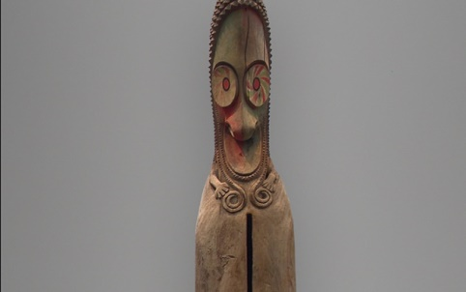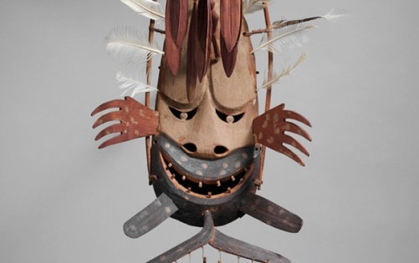
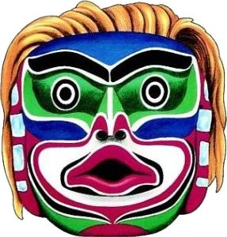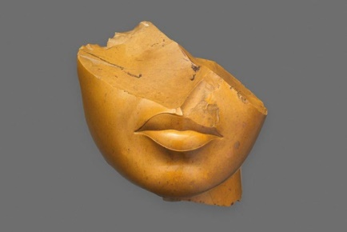
Instructional Strategies:
The teacher will ask students to sit in a table work and discuss on different types of masks (party masks, Halloween masks, Mardi Gras masks, etc…) while listening to Eric Clapton’s Behind The Mask., to open a discussion on the purpose of masks in today’s society. They start to have an idea of a mask, and they think what mask to create with paper Mache.
Following the order, depth, and sequence of the information presented in the content outline, the teacher will ask and seek answers to the following questions. Students answer the questions on the given paper as a purpose and meaning searching of the mask work.

Students answer the questions on their own paper after discussion.
Knowledge: What is a mask?
Comprehension: What can masks tell us about the people who make them?

Application: Can you think of another instance, other than the ones I have just explained, when we might wear a mask?

Analysis: Why do people adorn masks?

Synthesis: If you could pretend to be someone or something different for one day, what type of mask would you choose to wear to alter your identity?

Evaluation: Do you think it is a good thing to wear a mask once in a while to alter our identities?
Why?
What is your ideal mask?.........................

What kind of mask do you want to create?.......................

Circle and choose one of these level for your mask. Write more information on the line.
A - (EASY Level) Paper Mask - Drawing and painting your mask on paper……………………………………………..
B - (Medium Abilities of exploration) Do you like to use paper Mache?.........................................
C - Extension : (Difficult High Level Advanced)Do you want to explore different technique?...........
Standards : The student creates and communicates a range of subject matter, symbols, and ideas using knowledge of structures and functions of visual arts. - The student understands the visual arts in relation to history and culture.

Lesson 3
Students write on the given sketching paper, task analysis, outline of the work using graphic organizer
Students think reflect on their answers of the yesterday paper and breakdown the task of the project in stages.
Students will learn about symbolism, research it, and adorn their masks with their chosen symbols. Students will think about how to best express their individual selves and their culture as they see it through the symbols and elements they choose for their masks.
Instruction
As a class, students will brainstorm ideas of different emotions that are expressed on the human face
Students discuss and write demonstrate how facial features (especially eyes, cheeks, mouth, eyebrows) change as an emotion is expressed.
Students will then individually sketch ideas for three potential masks that communicate an emotion; they will later create their best mask design.
Students will also be encouraged to think of different “props” that could be incorporated into their mask to help communicate the emotion or to give greater interest to the mask--hats, hands, hairstyles, jewelry, etc.
Preview of the final questions
Did the student create a papier-mâché mask of a human face that expresses an emotion, and attach it to a background that relates to the mask?
Is the work neatly and carefully done?
Does the artwork show evidence of originality and creative thought?
Did the student use his/her class time wisely?

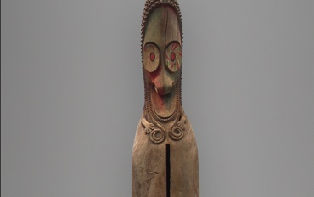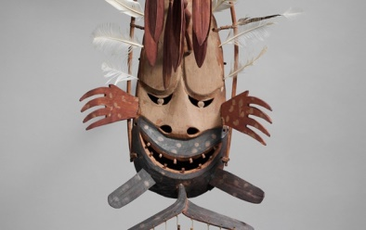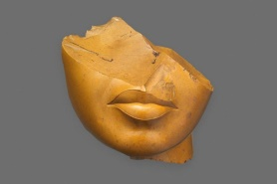

Lesson 4
Students will create their own mask out of plaster or paper Mache’.
They will work in teams to make on the molds and then will use paint and other items to decorate their masks.
Students will be given a plastic facial form that should be covered with a slab of modeling paper. (It is easier to press small pieces of the modeling paper with glue onto the form and then smooth them, press them together rather then leave them loose. )
Once the plastic form has been covered, students will need to build up and exaggerate the facial features with the modeling part of the mask, extensions in order to create the expression they have designed.
Steps of Paper Mache for Mask.
Do you have your project in mind?
Do you have the steps of the work programmed in your mind?
How many steps?
How Many Layers of paper?
What is a Mold?
What do you do during the process?
How many days you let it dry?
Can you refine your work? How?
How much concentration you have to use?
Lesson 5
Students will then begin putting the strips of newspaper on their armature with the papier-mâché paste. They will need to be reminded that smaller pieces of newspaper will be necessary in the detailed areas so that the expression they have created is communicated effectively. Five to seven layers of papier-mâché make a sufficiently strong mask.
Lesson 6
Students will use acrylic paints to add color to their masks. It is helpful for them to know to add white (highlights) to “higher” areas of the face (nose, cheekbones, forehead, etc.) if they want a realistic outcome.
Lesson 7
Students will be given a piece of matboard to design a background that is related to their mask. They may use acrylic paint, matboard scraps, construction paper, yarn, or whatever is available to add interest to their design. When the design is complete, students will attach the mask to the matboard with hot glue or E6000 glue.
Lesson Assessment 8
Students will be asked to individually complete a written rubric evaluation in which they will describe their mask, consider whether or not they were successful in communicating their intended emotion, and evaluate what was successful about their mask and what could be done to improve it.
Students will discuss orally the successful work and the work of their classmates and give suggestions for making improvements.
Answer the questions
Did the student create a papier-mâché mask of a human face that expresses an emotion, and attach it to a background that relates to the mask?
Is the work neatly and carefully done?
Does the artwork show evidence of originality and creative thought?
Did the student use his/her class time wisely?

